The show must go on!
Hello parents and guardians,
Below is a guide of the work children will be using during this time away from school. Students will bring home pencils, a sharpener and an eraser. Please return these when school commences.
Please find reading, writing and maths tasks on the below table for your child to complete. There will be extra resources at the end of your pack if you finish these tasks. While we understand that not all children may be able to complete the same amount of work we encourage everyone to have a go.
Writing Tasks | Reading Tasks | Maths Tasks
Brainstorm for an expository text | Reading eggs: Online program | Make, Numeral, Word
Introduction (What. Why learn about it) | Read or listen to child friendly news | ____ ____  and remove  ____ ____  makes leaves  ____ ____
Body information 1 (Why it is important for the community) | Read a text | 0-100  Number Chart find patterns.
Body information 2 (Where you can find it and what it looks like) | Read labels of objects around the house | Watched a maths video
Body information 3 (What people do there) | Used useful apps relevant to my learning, e.g. story online | Completed a work sheet
Body information 4 (How it could help others) | Made connections about a book I read or listened to. | Play a numeracy game
Conclusion (most important facts) | Made inferences about a book I read or listened to. | Email class teacher regarding work.
Added expository text features (diagrams, glossary, fact boxes) | Made predictions about a book I read or listened to.
Spell words during the day (golden word practise) | Golden word sight knowledge

Please use compass to contact us over this time period, we are more than happy to communicate to clarify any learning that is occurring at home.
Please go to the Reservoir Views online website to find all the links that will support student learning from home.
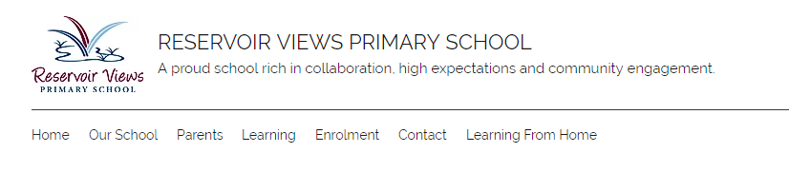
Google, Reservoir views primary school or
https://www.reservoirviewsps.vic.edu.au/

Writing
Students are to create an expository text about What is special in my community?
Expository is non fiction text that gives the reader information.
Discuss with your child a place in the community that is personal to them, such as a Mosque or Church, a local club such as footy, dancing, soccer or netball, the local library or the local park.
Students are to complete this task in stages.
Writing an expository text
Use the attached templates and follow these steps.
All sentences must begin with a capital letter and finish with a full stop. Don’t forget to read through writing and add more!
What to do: | Which template to use:
Step 1: Brainstorm
Watch this youtube video to help you:
Informational Writing for Kids- Episode 1: What Is It? https://www.youtube.com/watch?v=DN4d76QP_MA
Choose a place in your community that you want to write about.
List your ideas on the brainstorming template.
Step 2: Front cover
Write your title.
Take a photo of the place in your community and glue it onto the template.
Write your name - you are the author!
Step 3: Contents page
Write the headings on the contents page.
Leave the page numbers until you are finished writing your whole text.
Step 4: Introduction
Write the heading My Community Place.
Watch this video to help you write an introduction. https://www.youtube.com/watch?v=i6BTfNQiXXI
Include what it is and why it is important to know about it.
Step 5: Body paragraphs
Write a heading on each new page:
- Why is this place important?
- Where is the place and is inside?
- What do people do at this place?
- How is this place helpful for us?
Write under heading to tell your reader facts about your community.
Step 6: Conclusion
Write the most interesting or important thing about your community place.
If you like:
- include a glossary to tell the reader what different words mean
- include an index to show the reader which page to find information on
Step 7: Publish!  Put your pages in order.  Write page numbers on each page.  Staple your pages together and enjoy reading your book! | 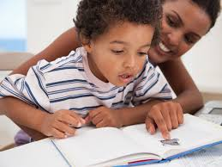

Try a narrative
Please also find attached a simple planner for creating a fictional story.
Practise writing your high frequency words
Please find attached some high frequency words (coloured tables below e.g. red, purple, golden, blue, green, orange etc) that your child can practise writing. You may write these in the back of your scrapbook.
Reading
Please find links that will be useful for your children to read and use during this time as well as apps that can assist their learning.
https://www.abc.net.au/kidslisten/news-time/ (google = Kids News)
https://www.abc.net.au/btn/ (google =BTN ABC)
Storyline online: https://www.storylineonline.net/
Some examples of good storyline texts are;
Book 1: https://www.storylineonline.net/books/carlas-sandwich/
Book 2: https://www.storylineonline.net/books/harry-the-dirty-dog/
Here are links to things students can do before during and after reading to assist in their learning. Please remember the number one goal is for reading to be enjoyable and to learn about new topics. If your child is reading texts that are too hard, or being asked questions that are beyond their understanding it may disengage your child and stifle their future learning.
Making predictions: https://www.youtube.com/watch?v=k09Q8A6Bxco
Making connections: https://www.youtube.com/watch?v=gP59YwkBuWs
Text to self: https://www.youtube.com/watch?v=UXymHkbA5Ng
Text to text connections: https://www.youtube.com/watch?v=O95uVRDALQI
Text to world: https://www.youtube.com/watch?v=bUeHGhwHRlg
Making inferences: https://www.youtube.com/watch?v=i_hbzv2EacM
Summarising/main idea: https://www.youtube.com/watch?v=mkZo2zVKJR4
Recording
Students may record their thinking using these skills by writing before, during and after reading in their scrapbook.
Reading eggs
Your Child has additionally been given a reading eggs account from the school, this can be downloaded from the app store or accessed online at https://readingeggs.com.au/ Or google = Reading eggs.
If students haven’t sat a placement test, please click on the green link on the right hand side of your screen. A placement test gives your child a reading level.

Maths
Here are some links for math videos children can watch.
Place value –
Tens and ones - https://www.youtube.com/watch?v=1F3AycEDksY
Hundreds, tens and ones - https://www.youtube.com/watch?v=omkDLmfvetk
Place value lesson - https://www.youtube.com/watch?v=T5Qf0qSSJFI
Teen numbers - https://www.youtube.com/watch?v=sL76_VtvtgQ
Teen numbers - https://www.youtube.com/watch?v=m1JOSkkpIPM
Counting –
Count by 1’s - https://www.youtube.com/watch?v=bGetqbqDVaA
Skip counting by 2’s - https://www.youtube.com/watch?v=GvTcpfSnOMQ
Counting by 5’s - https://www.youtube.com/watch?v=EemjeA2Djjw
Count by 10’s - https://www.youtube.com/watch?v=-gmEe0-_ex8
Addition and Subtraction –
Basic addition and subtraction lesson - https://www.youtube.com/watch?v=8cR_1Qi-tP4
Addition flash cards - https://www.youtube.com/watch?v=SEAKuerLbsk
Odd and even numbers -
https://www.youtube.com/watch?v=-kHtGbnYKGc&t=59s
Use different types of objects found at home to support counting and number skills. Such as toothpicks, lego blocks etc.
We will be giving students multiple activities that need them to generate a random number, please find the link to the following site that allows this. https://rolladie.net/#!numbers=1&sides=10&length=1&sets=&last_roll_only=false&totals_only=false&start=false. Or simply google = roll a die and select.

Numbers will show here, not all numbers have picture of dice.
Click in box to change the total numbers that could be shown.
Each click will give a new number
Make, Numeral, Word.
Roll a dice and, Make the amount (you can use toothpicks, Lego blocks ect) record the number and then the word.
Start with ones then expand. (Set dice at 9 then 99 then 999)
Reminding students that 10 ones makes 1 ten and that 10 tens makes 100.

Simple addition
Haves students roll a number and record, then roll another number record and solve by moving the total down and recording.

Simple subtraction
Have students roll a number record, roll another number, record the digit and then remove that amount and solve.
Finding patterns in number charts
100s chart, skip counting by 2s, 3s, 4s, 5s, 6s, 7s, 8s, 9s, 10s find patterns, e.g. starting from 0 and counting by 4s gives you an even number or counting by threes is 2 and one more.
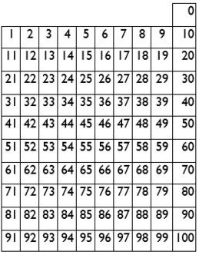
There will also be a number of worksheets and games attached for you and your child to use at your leisure.
Food bar graph, Place value worksheets, 0-10 numeral word collection.
Daily record.
Last of all we have placed scrap books in your child’s resource packs, each night please have them record their learning in the following areas, Reading, Writing and Maths. A simple sentence of
Today in writing I, Today in reading I, Today in maths I will be more than enough. Feel free to allow students to use these books as they wish.
Most importantly be safe and enjoy being teachers for a few weeks☺.

Why it is important.
Where it is and what it looks like.

What people do there.

My community
How it could help others.

(Title) _____________________

(Photograph
or drawing)

(Author/student name) _____________________
________________________________________________________________________________

_____________ _____
_____________ _____
_____________ _____
_____________ _____
_____________ _____
_____________ _____
_____________ _____
_____________ _____

(Heading/Intro)

(Importance)

(What people do there)

(Where/looks like)

(Helps others by)

(Conclusion)

(Spare page)

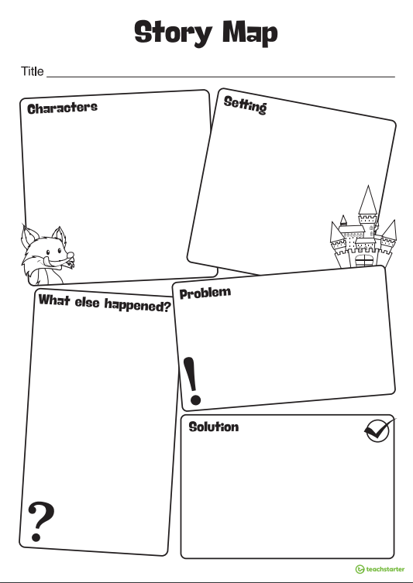

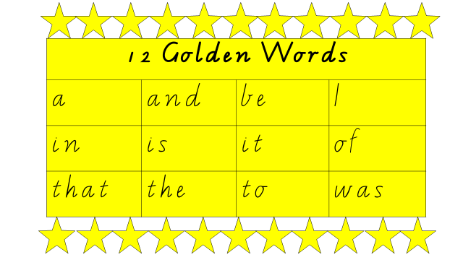 | 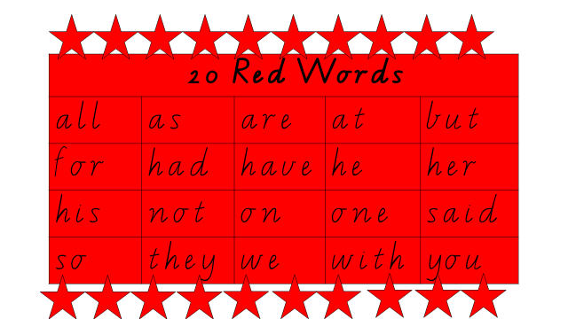
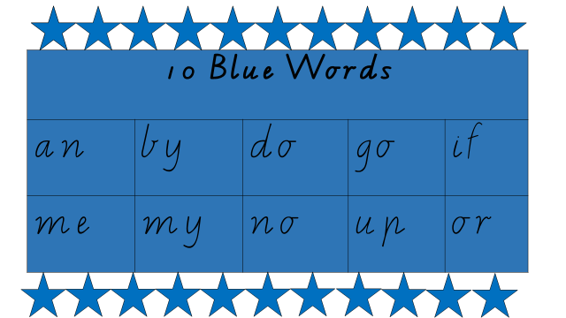 | 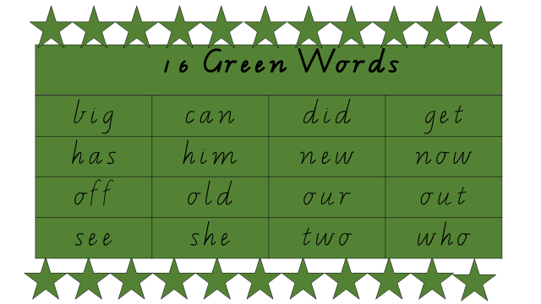
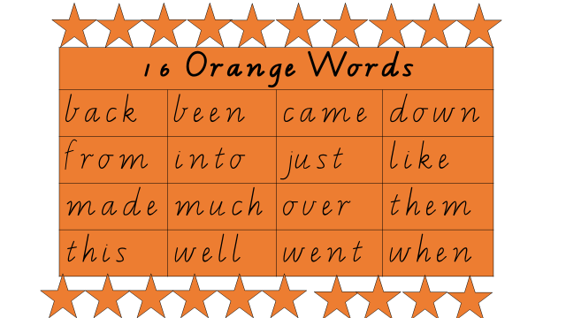 | 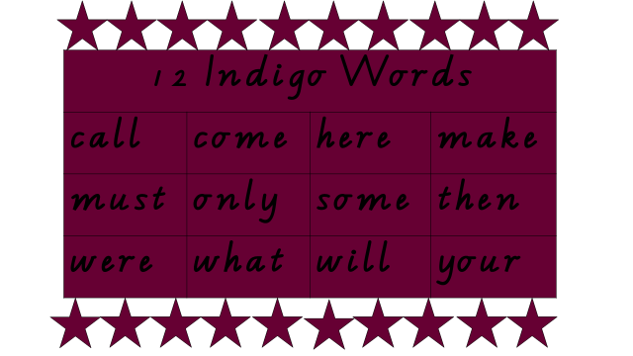
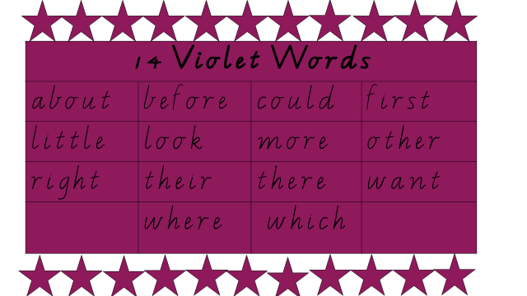 | 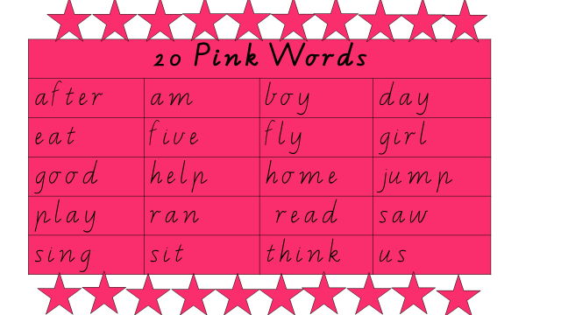
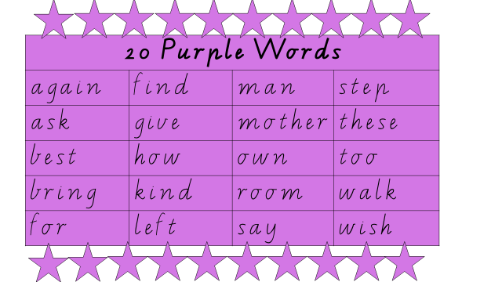 | 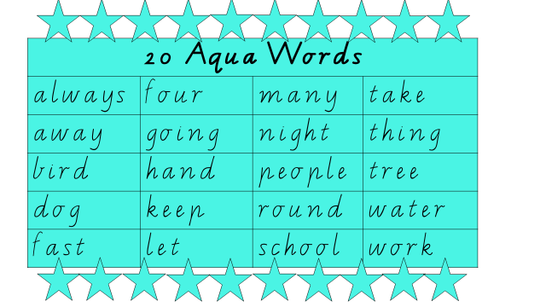
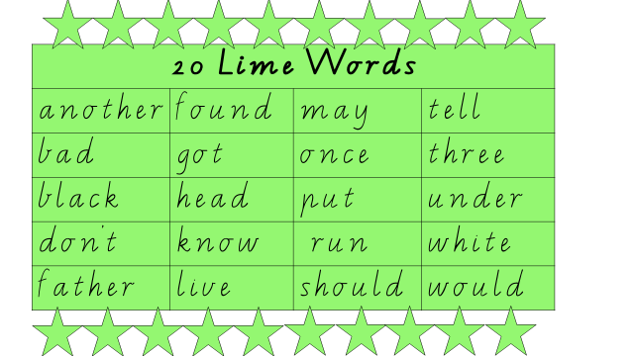 | 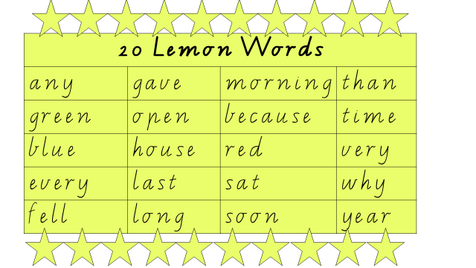
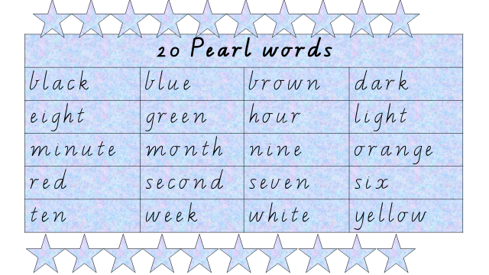 | 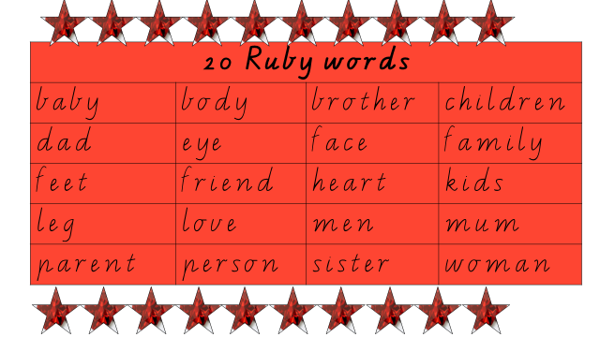
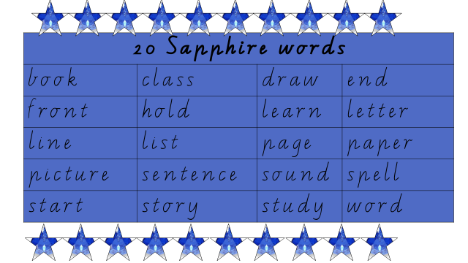 | 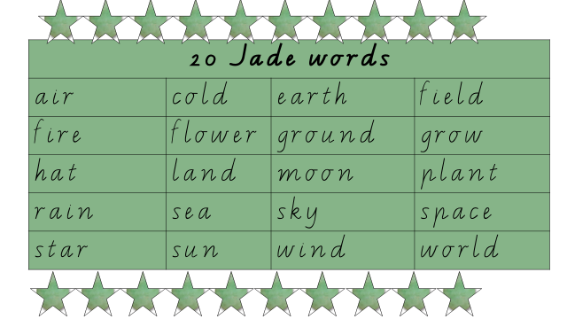

Hundreds | Tens | Ones
Numeral ________________ ________________________ _______________________
Word __________________ _________________________ _______________________

Tens | Ones
And
Tens | Ones
Makes
Tens | Ones

Tens | Ones
Remove/Take away
Leaves
Tens | Ones

