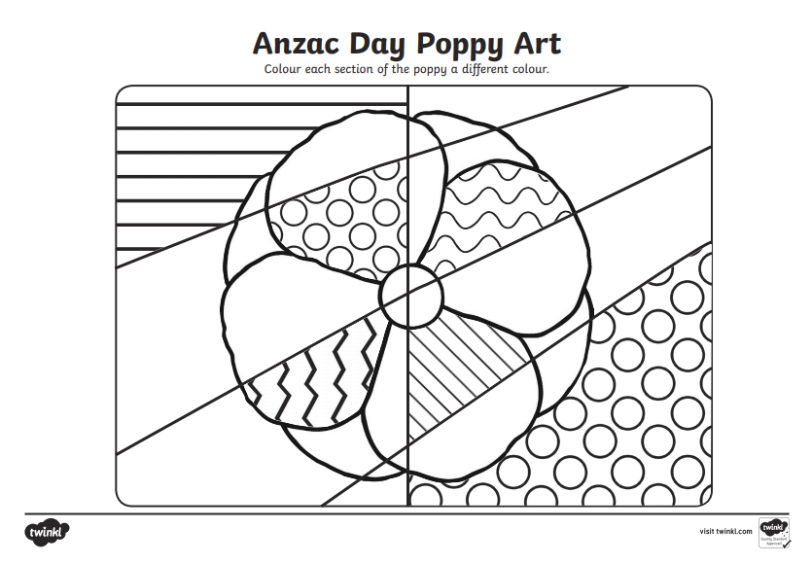

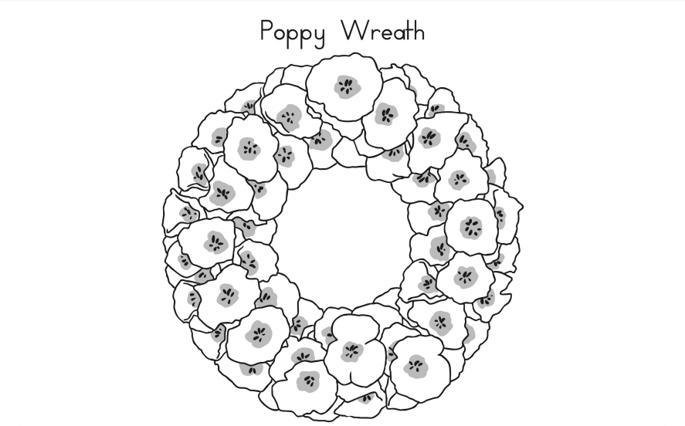

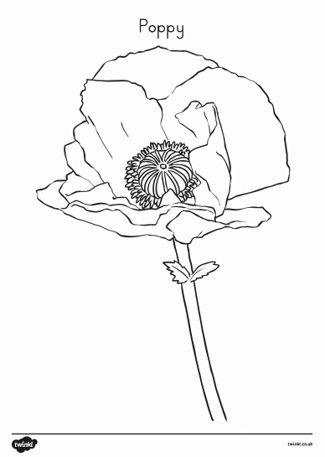

ANZAC Candle Holder

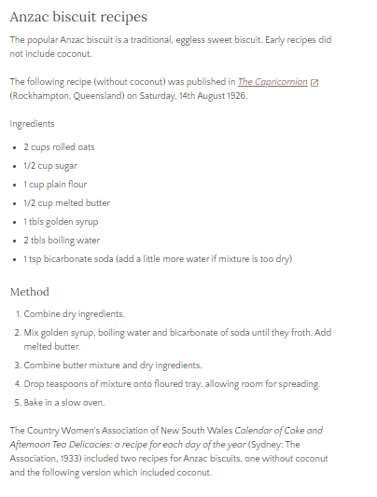

From the Australian War Memorial Website:

<https://www.awm.gov.au/articles/encyclopedia/anzac/biscuit/recipe>

Adult help required:

Thoroughly wash and cut the top off a 2 litre milk bottle

Use textas or sharpies to draw poppies or rosemary (for remembrance) on to the outside of the milk carton

Place some sand or pebbles in the bottom of the milk carton

Use and LED candle (flame-free LED candle for safety) in the bottom of the milk carton

Place outside or in the driveway to pay your respects on ANZAC Day.

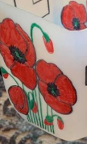

Egg Carton Poppies

<https://www.youtube.com/watch?v=NzW6NFY_UO0>

